We thank the Editor and the Reviewers for their constructive comments and suggestions. We have addressed the raised questions and comments below. Modifications are indicated in the “multiple-imputation-manuscript-tracked.docx” file using track changes. In our answers below, we refer to the corresponding page and line numbers in this tracked file's “All Markup – showing all revisions inline” display. The “multiple-imputation-manuscript-clean.docx” file is a clean version of the revised manuscript.

Reviewer #1:

General
- Some imputation methods, mostly the ones not based on sampling with variability, artificially and incorrectly reduce the variability in the data and might introduce bias (for example, if all missing ages are imputed by the same age value, mean/median or other). This presumably holds for the PMM algorithm, too (l. 222ff.). A discussion of this appears appropriate.
PMM imputes the missing values using the specified imputation model and indirectly uses these predictions via the selection of the candidate donors from the observed values. Thus, it not only preserves the randomness in the imputation but also ensures that imputed values are plausible. We included this statement in the paper. [Pages 11&12, lines 235–238]
- l. 231ff.: It is not obvious from the description, at least not to me, why PMM is "a reliable method against model misspecification" and I would like to see further elaboration.
We elaborated on this in the paper. [Page 11, lines 233–235]
- I envisage applications of imputation methods mostly for large population PK/PD models using clinical phase 2 and phase 3 data. Phase 1 data rarely have missing values due to the typically well-controlled environment. The large PK/PD models are frequently built under time pressure. In order for the approach to catch on in practice, readers should be provided with a clear overall algorithm, including identification of imputation models and everything else. Can the authors provide some sort of algorithm for creating an appropriate imputation approach, going as far as discussing semi- or fully automated algorithms.
It seems key for a wider use of these methods that the authors support pharmacometricians by a clear flow and support with (semi-) automated procedures. Please consider an algorithm definition for the entire approach, similar in layout as the current Table 2, substantially expanding the current Figure 1 into a figure that guides the modeler through all steps in detail.
Much of what is presented and discussed in this manuscript is published elsewhere (including the documentation of the mice R package, https://doi.org/10.18637/jss.v045.i03). This is acknowledged by authors ("Our study is not the first to present an MI workflow in pharmacometrics, but it is the most comprehensive", l. 522/23). Still, I see value in adaptation of the existing methods to pharmacometrics applications, in particular if the authors could move closer towards a very clear algorithm (as suggested in the previous paragraph).
Thank you for this very important comment. We have expanded our figure 1 based on your suggestion and we also adapted the manuscript accordingly to make sure that it is more pharmacometrics focused. [Page 8, lines 156–160; Page 10, line 195; Page 14, line 296; Page 15, line 314; Page 16, line 349; Page 17, lines 370 & 377]
- Simulation scenarios with half or more of the data missing appear very unrealistic to me but might still be interesting for completeness of the assessment. It would be useful if the missing records with 50% of the data missing would include the same missing records as the data sets with 6.25%, 12.5%, and 25% missing data, but I appreciate that this might be more difficult to implement. It could be done if the 75% missing data would be created first and some of the data be put back in to achieve other percentages of missingness.
The manuscript should at least be clear on whether or not these missing records are subsets of one another (l. 450ff.).
It is indeed known that not all observations provide the same amount of information on the parameters of interest. Comparability of e.g. the 50% and 25% missingness scenarios may thus be undermined when the occurrence of missingness differs in both scenarios. It is our understanding that this is what the Referee hints at when suggesting to subset the percentages of missingness. However, the effect is expected to be negligible in our analysis as we repeated each scenario many times. Consequently, the occurrence of missingness varies in each simulation, which is expected to average out over the scenarios. Therefore, as suggested by the Referee, we now clarified that “Missing records are not subsets of one another. The high number of iterations is expected to minimize the impact of different occurrences of missingness across missingness scenarios, thereby guaranteeing comparability.” [Page 22, lines 491–493]
- Computer runtime is an issue when it comes to full pop PK models with thousands of records doing covariate analysis and, on top, multiple imputation at each step. This aspect should be added to the discussion, and it might be interesting to see the runtimes for the warfarin model using a very small data set, best on a small computer such as a laptop (the authors appear to have used a supercomputer).
Thank you for this comment. We added the runtime aspect to the discussion section and reported the runtime for our Warfarin case study, as well as the infrastructure we used to run it. [Page 30, lines 687–694]
- One of the advantages and simultaneously disadvantages with R is the availability of a huge number of packages written by thousands of authors, largely unknown. I suggest that the authors of this manuscript help the readers by providing comments on the quality of the packages they reference in Table S1. How far can these be trusted for correctness? The authors comment that ignoring the mechanisms of missingness can cause severe biases. Wrong results based on errors in R packages have the same potential of causing harm to patients.
We added the status and main developer of these packages in the footnotes of Tables S1 and S2. Additionally, we included some metrics suggested by the packagemetrics package (https://ropensci.org/blog/2017/06/27/packagemetrics/) in the Supplementary Code and Dataset.
- It would substantially strengthen the point that (multiple) imputation is important and can be done if the authors could reference pharmacometrics works where this has been done, best in submission activities.
We emphasized in our discussion that the application of multiple imputation in pharmacometrics has been growing recently, and we cited several pharmacometrics works. [Page 26, lines 583-584]

Details
- The cover letter states that "The authors declared no competing interests in this work" while the author form states that "There is a conflict of interest. Erwin Dreesen received consultancy fees from ...".
The statements look contradictory.
We included it initially for full transparency, but to avoid any confusion, we have now removed it and stated that we have no conflict of interest regarding this work.

Abstract:
- it is stated that multiple imputation is preferable over single imputation with not even a hint of why that may be.
We explained that “multiple imputation better reflects uncertainty estimates than single imputation, regardless of the degree of missingness”, which makes it preferable over single imputation. [Page 2, lines 45-46]

Introduction:
- It is a bit surprising that industry guidances such as the ICH guidance documents are not referenced (for example ICH E9, section 5.3 on missing values and outliers). This guidance complicates the matter by suggesting performing the analyses on different data sets and I wonder how the approaches suggested here fit into this context. Such a discussion is probably best placed in the discussion section, not the introduction. The authors could even go as far as suggesting an update of the guidance document to encourage using imputation techniques.
We cited the ICH E9 document in the discussion section. [Page 26, line 579]
Regarding the suggestion to perform analyses on different data sets, we believe that the document intends to “demonstrate a lack of sensitivity of the principal trial results to alternative choices of the set of subjects analyzed”, rather than to handle missing data.

Simple methods for handling missing data:
- l. 93ff: "in biomedical/pharmaceutical research where it is not uncommon for more than half of the data to be incomplete": I have never seen a clinical data set with more then half the data incomplete and doubt that this is "not uncommon", this appears to be a bit of an exaggeration.
We added three references where the degree of data missingness was above 50% to support our argument (i.e. refs 10, 13, and 14). [Page 5, line 95]
- l. 107ff: imputing by means or medians reduces variability estimates and acts as another kind of shrinkage in pharmacometrics applications, which could be mentioned here.
While median or mean imputation does indeed reduce variability estimates, this does not translate into an increasing parameter shrinkage. In fact, our case study showed that parameters tend to have lower shrinkage when using median imputation than when using multiple imputation (please see the figure below). Hence, we believe a direct translation from the method of handling missing covariate into the parameter shrinkage is not straightforward.
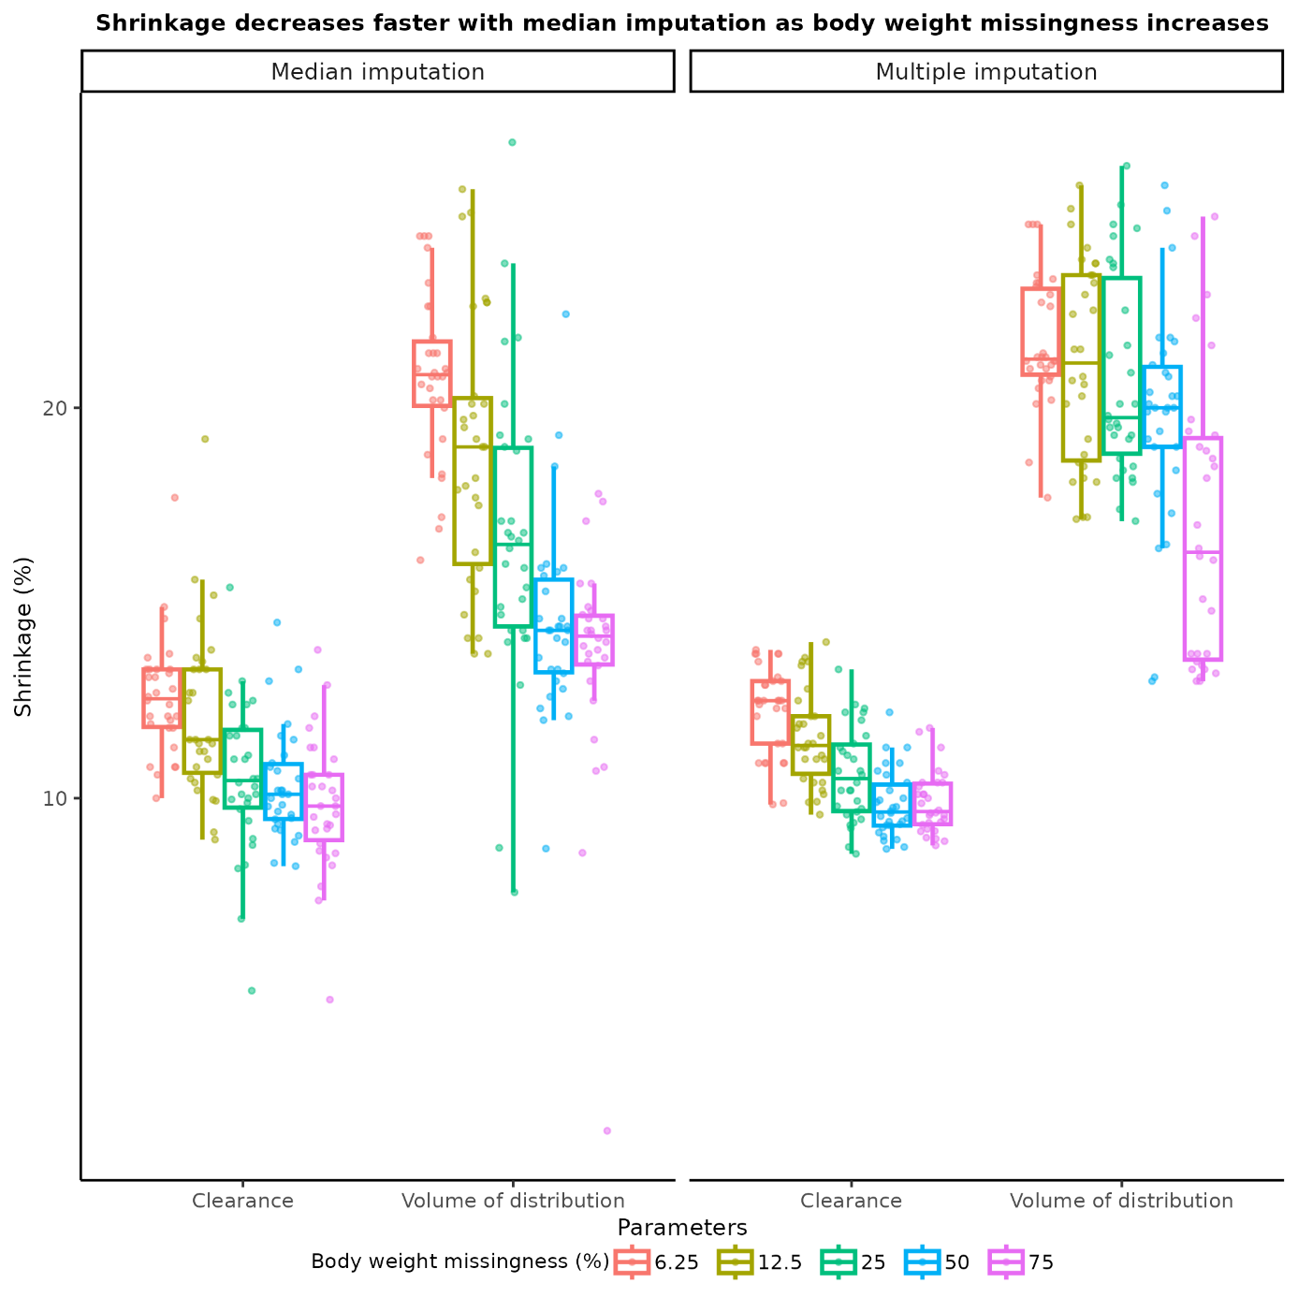
Multiple imputation of missing covariate data:
- l. 141ff: The references provided are useful. The classic works of Dempster, Laird, and Rubin (1977) and the EM algorithm should be mentioned here, too, I think.
Reference: https://doi.org/10.1111/j.2517-6161.1977.tb01600.x
Thank you for this comment. We added the reference and stated that EM is another valid approach for missing at random data. [Page 8, lines 145-146]
- l. 170ff: splitting the data into two sets requires a reasonably large data set to start with, which is usually only available with clinical Phase 3 data.
It should be helpful if you could reference an R package that you deem to be useful while the reference to Heymans and Eekhout with applications in SPSS (which is not a pharmacometrics software) appears not very useful.
The reference by Heymans and Eekhout provides some R functions to compare the characteristics of the two groups with observed and missing covariate information. We have added this information to our manuscript. [Page 9, lines 176-178]
- Table 2: I don't see why a table is created to show an algorithm. A numbered bullet-list appears more appropriate and can be placed exactly into the text where it is discussed (while a table is a floating object).
- Various places in Table 2: "each of the k missing covariates" should be "each of the k covariates with missing values" (it is not the covariates that are missing but the values).
- It seems that an "else" statement is missing for step 3 ("If a linear regression model is fit"), it seems undefined what to do if the model is not linear (and maybe none of the imputation models).
- Actually I don't see why the restriction to linear models is there at all, it seems that other models, for example any model fit using least-squares regression, could be employed.
- There should be a short discussion on how much results might differ depending on the sequence of covariates imputed, appreciating that generalization is difficult and, for large numbers of sampling steps, it averages out.
We implemented your suggestions regarding Table 2 and added it directly to the manuscript in the numbered bullet list. [Pages 12-13, lines 259-283].
Regarding the discussion, we added this “FCS has the main advantage of not having to pre-specify a sequence in which covariates are imputed, thus ruling out that there might be any impact of the chosen sequence”. [Page 14, lines 294-295]. To what extent the results of alternative approaches are impacted by the choice of sequence of imputation would require an extensive, dedicated simulation study, which is outside of the scope of our work.
- l. 267ff: the suggestion that "if the pharmacometrics model includes an interaction term, this term must also be in the imputation model" is justified but very hard to implement in practice: such interaction terms are commonly not defined from the very beginning in PK/PD modeling but introduced during model development. This in turn would ask for changing the imputation model during model development by adding an interaction term.
Thank you for this important comment. We acknowledged the challenge in our manuscript. [Page 14, lines 302-305]
- l. 281ff: there are different formulas for BMI and eGFR, some of which include other covariates such as race.
We added two references for our two equations. [Page 15, line 318]
- l. 307ff: FCS is not spelled out on first occurrence but on third occurrence later.
We have spelled out FCS on its first occurrence. [Page 12, lines 252-253]
- l. 363ff: clearance and volumes are commonly assumed to be lognormally distributed, not normally. Is this what is meant by "approximately" normally distributed?
I note that optimization (model fitting) generally happens in the multivariate normal space after transformations into this space.
Individual PK parameters are indeed known to be lognormally distributed. However, in our manuscript, we referred to the typical PK parameters, which are normally distributed, especially if prior log-transformation is not performed (e.g., as in mu-referencing).
- l. 401: "to be converged" should be "to have converged".
We have corrected the phrase. [Page 20, line 440]
- l. 406ff: "high-quality imputations should have a similar distribution to that of the observed data" would be correct in MCAR situations but appears incorrect in the settings discussed here (non-MCAR).
The Referee is correct. We have rephrased the sentence accordingly: “The rationale behind this approach is that high-quality imputations should be plausible.” [Page 20, lines 446–447]
- Table 3: it seems discomforting to see that a larger fraction of models did not converge. The models not converging are most likely not completely random either but dependent on, for example, extreme covariate values. This appears to be a major issue with respect to credibility of the methods and the analysis. Please provide a very specific description of how convergence (or lack thereof) was diagnosed here (best as footnote to the table).
We removed Table 3 since the convergence rate for both multiple imputation and single imputation is 100% now.
- l. 465 ff: the description of the implementation is insufficient: in particular, which fitting algorithm was used (FOCE, FOCEI, SAEM, or other)? I can easily imagine differences in convergence rates between algorithms.
We have added the information regarding the fitting algorithm to our manuscript. [Page 23, line 510]
- l. 560: the definition of "multivariable" missing covariates is not clear to me, please provide a brief description here or rephrase.
We changed “multivariable” to “multivariate” on Page 27, line 626. The definition of multivariate missingness is provided on Page 9, lines 186-187 of our manuscript.
- l. 586ff: general superiority cannot be established based on few case studies, different data sets may well produce different results.
The referee is correct. However, multiple imputation has consistently been shown to be superior to single imputation in biostatistics.¹ Therefore, we believe we can generalize its superiority without the need for additional case studies.
- The references require another proofreading:
Ref 9 has author names all in uppercase.
Ref 10 has "Certara USA I." as author.
Refs 13, 15, 18, 46, 53 are not helpful in finding the reference, please provide a URL.
Ref 20 has no publisher nor journal.
Ref 24 should have the journal name spelled out.
Ref 36, a book, has the publisher location, other books do not.,
We made sure that the format for these references is correct. [Page 33, lines 724-725; Page 33, lines 726-727; Page 34, lines 738-742; Page 34, lines 745-748; Page 35, lines 753-754; Pages 37-38, lines 823-826; Page 38, lines 847-848; Page 35, lines 757-758; Page 35, lines 767-769; Page 36, lines 793-794]
- Figure 2: "(a)" is probably better one of the standard footnote symbols (asterisk, hashmark, etc.).
We replaced (a), and (b) in our Figure 2 with (#) and (‡), respectively.
- Figure 3 seems useless for concluding anything from it, and the width of the kernel smoother appears too small.
Thank you for this comment. We finetuned the figure to enhance the visibility of the kernel smoother and put the figure into the supplementary file. [Page 23, line 512]

Reviewer #2:
- P13, L270-277: It is stated, that the outcome variable must be included in the imputation model, e.g., drug concentrations at all time points. While for longitudinal covariates, such as SCr, this might be best, I'm not sure whether taking multiple concentration measurements as predictors for the imputation in the presented case example is beneficial, as the imputed covariate weight does not change substantially in such a short time (in the provided R code, it looks like authors then simply average over imputed weights at different timepoints with quite large variability ranging from 62 to 104 kg in subject 24 in the first imputation run). Can the authors please elaborate their reasoning for this approach instead of, e.g., initially estimating PK parameters without covariate effects and using estimated individual PK parameters (Cl, V etc.) in the imputation? (Authors briefly mention this approach in the discussion, however don't elaborate in more detail)
Follow-up to comment 1: Authors use ID, TIME, and AMT for the imputation:
- ID is a randomly assigned number, is it reasonable to include this variable in the imputation?
- TIME (similar to concentration at different timepoints) seems to complicate the imputation as at different timepoints, different weights are predicted for the same subject and authors then simply average over imputed weights per subject
- While the applied dose seems to be useful for imputation, at "non-dosing timepoints", AMT is zero for most rows. Wouldn't it make sense to only include AMT at dosing-events, because giving a dose vs not giving a dose does not influence weight but given dose-amount might be important?
Thank you for this comment. We performed additional analysis using the estimated individual PK parameters as predictors in the imputation model (model 2) instead of time and drug concentration (model 1). We noticed that the performance of multiple imputation is worse for model 2 compared to model 1. We believe the reason is that time + drug concentration are better predictors for the missing body weight than the estimated individual PK parameters.
For the second part of the comment, we agree with the referee regarding removing ID from the imputation model. We kept TIME in the imputation model because we wanted to use as many as possible to ensure the imputation model performs best, following White et al.’s recommendations.² We then averaged WT per patient since WT is a time-invariant covariate in our case. For AMT, we kept it in model 1 and removed it in model 2, as AMT is highly correlated with WT in model 2. The correlation matrix for both models in the scenario with 12.5% body weight missing is presented in Figures 1 and 2 below.
We also removed the IIV from Ka to make our model more stable. This in turn led to the convergence rates for our both imputation methods to be 100%.
The changes we made for this comment are in [Page 22, lines 483; Page 22, lines 498-502; Page 24, lines 529-532; Page 24, lines 538-539; Page 25, lines 552-566; Page 29, lines 647-648; Pages 29&30, lines 658-673].
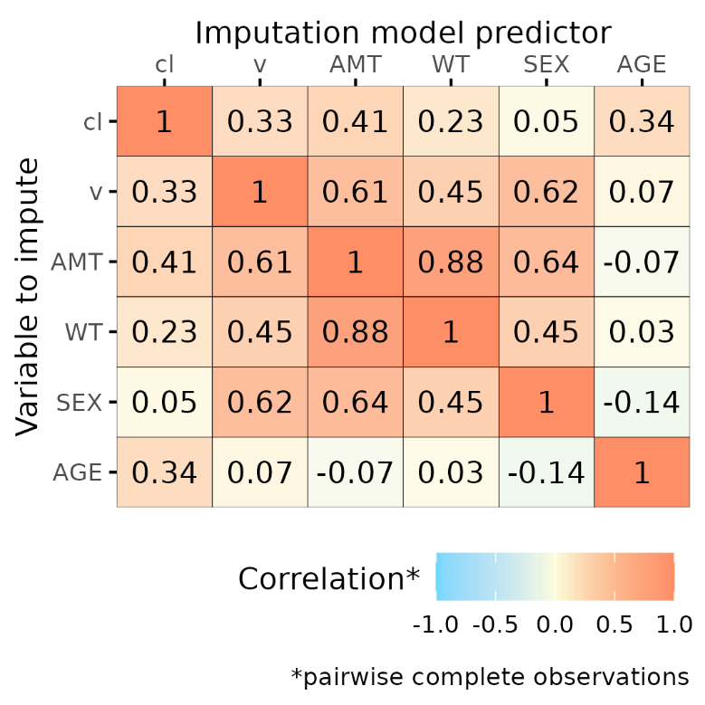
Figure 1. Correlation matrix for the model with estimated individual PK parameters as predictors
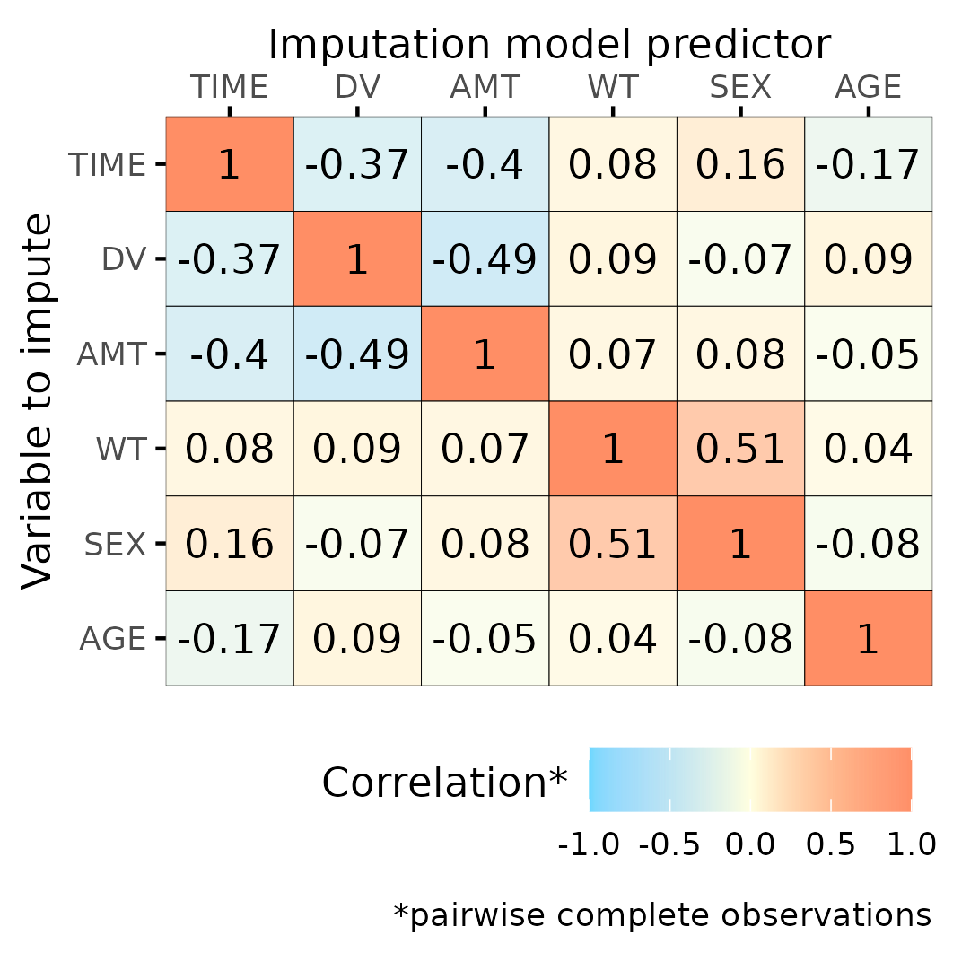
Figure 2. Correlation matrix for the model with time and drug concentrations as predictors
- P13, L278ff: Considerations on how to handle derived covariates is very interesting. For a tutorial, it would be helpful to have a simple (dummy-) code snippet to illustrate the three options.
We provided code snippets to demonstrate the three options in our Supplementary Code and Dataset. [Page 16, lines 347-348].
- P17, L366: Could you please elaborate, what transformations are required before applying Rubin's rule to random effects estimates?
We added log-transformation as an example. [Page 19, line 376]
- It would be interesting to see point estimates and standard error biases for the other estimated parameters, i.e., ka, Cl, and V (maybe in the supplements), and not only for weight effect on Cl and V.
We added these figures to our supplementary materials (Figures S2-S3 & S6-S7). We also reported the results for these structural PK parameters. [Page 25, lines 535-536; Pages 24&25, lines 546-551; Pages 25&26, lines 567-576]
- A more in-depth discussion for figures 4 and 5 would be helpful, i.e., what results are expected/desired would be helpful, e.g., obviously small relative biases for estimates, but also more consistent and potentially larger relative biases for standard errors due to uncertainty coming from missing values.
We reported additional overall results [Pages 24&25, lines 544-551], and we provided more substantial discussion regarding these results [Page 28, lines 639-646].
- The provided R code in the supplemental material is highly appreciated. However, more comments/ more detailed description of what is done in the provided R code would be helpful for pharmacometricians that want to apply MI in their analysis, especially as this is a tutorial.
We added more comments and detailed descriptions to our R code in the Supplementary Code and Dataset.
- It is perfectly reasonable to apply the median of the weights in the complete dataset to log-transform weight in the PK model in order to compare the resulting estimates. However, a naïve user might be tempted to apply the median of the imputed weights for the log-transformation which would result in non-reasonable pooling of the estimates with Rubin's rules. Thus, it would be helpful to highlight in this tutorial, that for a real-life application where no complete dataset is available, a fixed value (e.g., 70 kg or median of observed bodyweights) should be utilized to log-transform weights in all imputed datasets.
Thank you for this comment. We clarified that we used the median observed body weight of each incomplete dataset for imputation [Page 22, lines 496-497], and we cantered the body weight effect around the median observed BW of the complete dataset, which is 71.7kg. [Page 22, lines 485-486].

Editorial Office Comments:
- The author contributions section can be removed, as it is not required for this manuscript type.
We removed the author contributions section.

References
1. Molenberghs G, Verbeke G. Models for Discrete Longitudinal Data. Springer New York: New York; 2006.
2. White IR, Royston P, Wood AM. Multiple imputation using chained equations: Issues and guidance for practice. Statistics in Medicine. 2011;30:377-399.

